**Requirement Gathering and Analysis Phase**

**Data Flow Diagram & User Stories**

|  |  |
| --- | --- |
| Date | 06-07-2024 |
| Team ID | PNT2022TMID SWTID1720175019 |
| Project Name | Nexus Learn-Online Learning Platform |
| Maximum Marks |  |

**Data Flow Diagram:**

**Entities:**

1. **User**: Includes learners, instructors, and admins.
2. **Registration**: Process for users to sign up.
3. **Login**: Process for users to authenticate and access the platform.
4. **Profile Management**: Allows users to manage their personal information.
5. **Course Catalog**: Repository of available courses.
6. **Course Details**: Specific information about each course.
7. **Course Enrollment**: Process for users to enroll in courses.
8. **Learning Management**: Delivery of course content, tracking progress, interactivity.
9. **Certification**: Issuing certificates upon course completion.
10. **Payment**: Handling course payments and subscriptions.
11. **Notifications and Messaging**: Communicating with users.
12. **Admin Management**: Overseeing platform operations.

**Relationships:**

* Users register and log in to access the platform.
* Users manage their profiles.
* Users browse the course catalog and view course details.
* Users enroll in courses.
* Learning management delivers course content and tracks progress.
* Users receive certificates upon course completion.
* Payments are processed for course enrollment and subscriptions.
* Notifications and messaging keep users informed.
* Admins manage platform operations.

**Explanation:**

1. **User**:
   * Users start by registering on the platform.
   * Once registered, they log in to access the platform.
2. **Registration**:
   * The registration entity handles user sign-up.
3. **Login**:
   * The login entity authenticates users and grants access to the platform.
4. **Profile Management**:
   * Users manage their personal information and settings.
5. **Course Catalog**:
   * Users browse available courses.
6. **Course Details**:
   * Users view specific details about courses.
7. **Course Enrollment**:
   * Users enroll in courses they are interested in.
8. **Learning Management**:
   * Course content is delivered, and user progress is tracked.
9. **Certification**:
   * Users receive certificates upon course completion.
10. **Payment**:
    * Handles payments for courses and subscriptions.
11. **Notifications and Messaging**:
    * Keeps users informed and allows for communication.
12. **Admin Management**:
    * Admins oversee platform operations and manage users and courses.

Diagram:

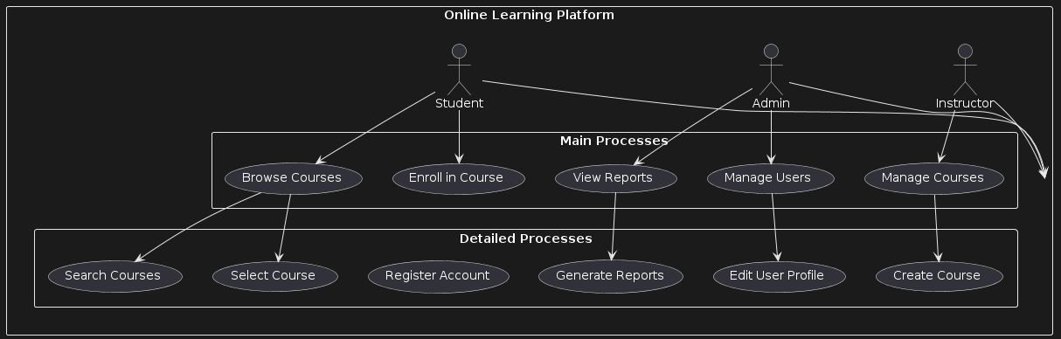

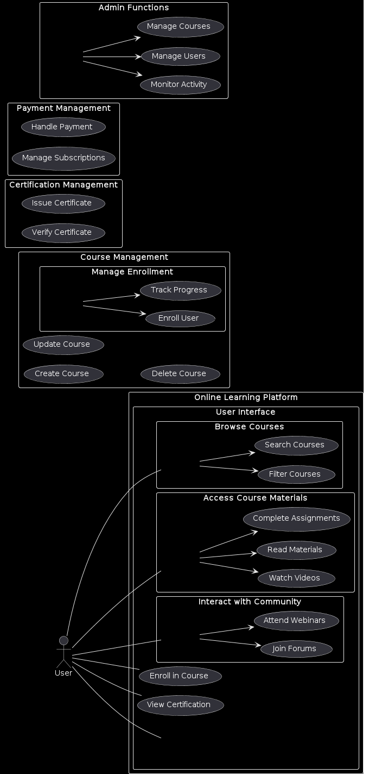

**User Stories**

| **User Type** | **Functional Requirement (Epic)** | **User Story / Task** | **Acceptance criteria** | **Priority** | **Release** |
| --- | --- | --- | --- | --- | --- |
| User  (Web User) | Registration | As a web user, I want to register for an account | The web user can successfully create an account using email and password | High | Sprint 1 |
|  | Login | As a web user, I want to log in to my account | The web user can log in using correct credentials and sees the dashboard | High | Sprint 1 |
|  | Browse Courses | As a web user, I want to browse available courses | The web user can see a list of available courses with basic information | High | Sprint 1 |
|  | Course Details | As a web user, I want to view detailed information of a course | The web user can see detailed course information including syllabus, instructor, and reviews | High | Sprint 1 |
|  | Course Enrollment | As a web user, I want to enroll in a course | The web user can enroll in a course and see it in their enrolled courses list | High | Sprint 2 |
|  | Learning Management | As a web user, I want to access course materials | The web user can access video lectures, reading materials, and assignments | High | Sprint 3 |
|  | Certification | As a web user, I want to receive a certificate on completion | The web user receives a digital certificate upon completing all course requirements | Medium | Sprint 4 |
|  | Notifications | As a web user, I want to receive notifications | The web user receives notifications for course updates, deadlines, and messages | Medium | Sprint 4 |
| User  (Mobile User) | Registration | As a mobile user, I want to register for an account | The mobile user can successfully create an account using email and password | High | Sprint 1 |
|  | Login | As a mobile user, I want to log in to my account | The mobile user can log in using correct credentials and sees the dashboard | High | Sprint 1 |
|  | Browse Courses | As a mobile user, I want to browse available courses | The mobile user can see a list of available courses with basic information | High | Sprint 1 |
|  | Course Details | As a mobile user, I want to view detailed information of a course | The mobile user can see detailed course information including syllabus, instructor, and reviews | High | Sprint 1 |
|  | Course Enrollment | As a mobile user, I want to enroll in a course | The mobile user can enroll in a course and see it in their enrolled courses list | High | Sprint 2 |
|  | Learning Management | As a mobile user, I want to access course materials | The mobile user can access video lectures, reading materials, and assignments | High | Sprint 3 |
|  | Certification | As a mobile user, I want to receive a certificate on completion | The mobile user receives a digital certificate upon completing all course requirements | Medium | Sprint 4 |
|  | Notifications | As a mobile user, I want to receive notifications | The mobile user receives notifications for course updates, deadlines, and messages | Medium | Sprint 4 |
| Instructor | Course Creation | As a tutor, I want to create new courses | The tutor can create new courses with syllabus, materials, and details | High | Sprint 2 |
|  | Manage Courses | As a tutor, I want to update my courses | The tutor can edit existing courses and update content | High | Sprint 3 |
|  | Interact with Learners | As a tutor, I want to interact with learners | The tutor can participate in discussion forums and live webinars | Medium | Sprint 3 |
| Admin | User Management | As an admin, I want to manage user accounts | The admin can add, edit, and remove learner and tutor accounts | High | Sprint 2 |
|  | Course Management | As an admin, I want to manage all courses on the platform | The admin can oversee all courses, including creating, updating, and deleting courses | High | Sprint 3 |
|  | Platform Monitoring | As an admin, I want to monitor platform activity | The admin can view reports on user activity, course enrollments, and platform performance | Medium | Sprint 4 |
|  | Notifications | As an admin, I want to send notifications | The admin can send platform-wide notifications to users | Medium | Sprint 4 |